**Bullet Hell Games**

Want to fight the enemies surrounding the game environment in your phones? Are you a shooting and fighting game lover? Well, this is the best option for mobile entertainment for you. Bullet Hell games or Shoot ‘em up games are present for mobile gamers in a wide number. These games entered the gaming industry like storms disrupting away the whole gaming scenario at a single go. Screen covered with enemy bullets is to be survived with various actions, adventures, and entertainment in this danmaku*.*

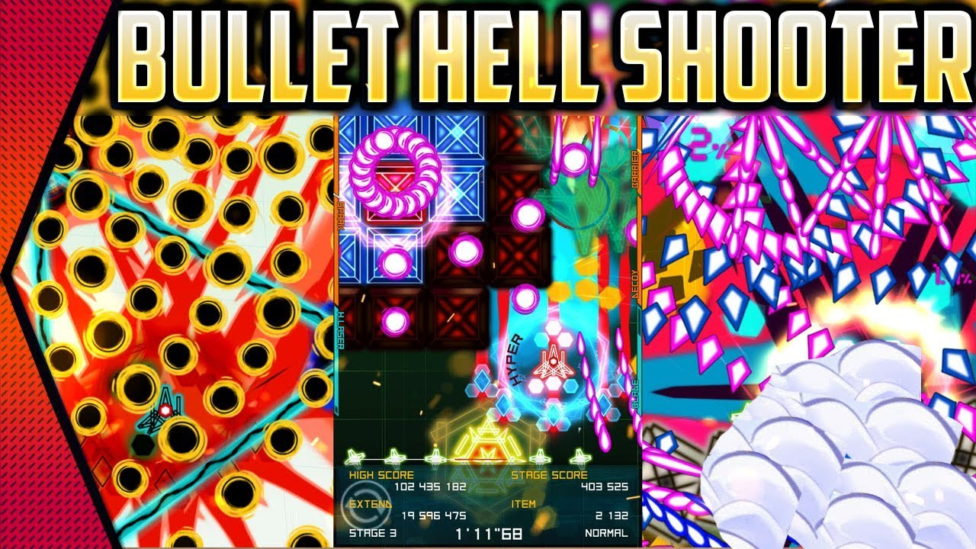

Bullet Hell games entered the gaming industry in the 1990s for the scrolling shooters. Space Invaders is the first parent release in this genre that used aliens as inspired by the War of the Worlds movie! The fertility in Bullet Hell gaming genre increased in 1978 with seminal space invaders released by Japan. Then various releases came like in 1979, Namco’s Galaxian, in 1981, Konami’s Scramble, Robotron: 2084 in 1982 till the present day’s mobile Bullet Hells like ShooMachi, Squadron, and a lot more.

Bullet Hell Games are a fascinating and unique genre in the gaming industry. These are the shooting mechanics with the incredible idea of shooting reversed on the players. PC and PS gaming fun is now enhanced with these Bullet Hell games in the mobile gaming industry. From Bullet Hell Monday to any game around the week, these games have provided variant shooting sequences and exposures.

**Top Bullet Hell games:**

Traveling, gaming, working, everything is fascinating and entertaining with the Bullet Hell genre in the Shoot ‘em up gaming sector. These games provide an immense amount of energy rise helping you have good blood pressure and refreshment with the game-play. Bullet Hell games are available in a monstrous amount in the market, some of the top ones are as follows:

* **Bullet Hell Monday:** This Bullet Hell Monday is the best Bullet Hell game present for iOS and Androids. This game has a variety of adventurous experiences with its three modes that are Chapter, Challenge, and Endless. These modules have plenty of upgrades and features and variance in difficulties to enhance the gameplay experience. From beginners to advanced gaming pro, these Bullet Hell games have a variety of features for everyone with changing difficulty at each game level that passes by. With many bullets, enemies, lasers, and features, this game is a hitbox among gamers for satisfying shooting game experiences.

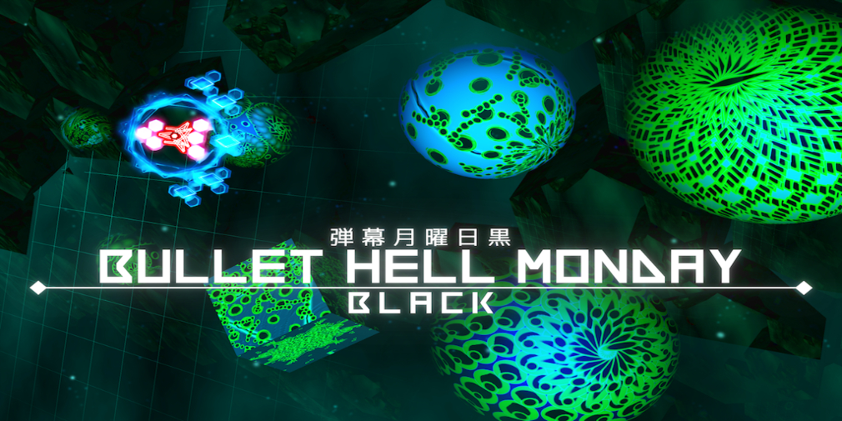

* **Air Attack 2:** The name of the game suggests the whole objective behind the gaming experience that is provided. This gaming experience is designed specifically for androids. The ships move around firing on each other and one needs to strategically manage the playing by targeting others and saving themselves from the fires. This is just like a world war era with 22 campaign missions, and a survival mission. The amazing 3D graphics enhances the shooting experience that is provided with this game. This is an easy to play gaming technique for gamers of beginner to advance level gaming skills.



* **Phoenix II:** This extraordinary game is just like a phoenix for stressed individuals. Phoenix II has around 75 upgrades with various enemies and missions and fighting experiences for extraordinary adventures. Unique levels of these fascinating games reset every 24 hours providing new experiences for the gamers and hence enhancing its user-base. The changes do not occur with the levels but in fact, every level changes with each day that is a unique characteristic shown by it. Phoenix II provides the leader boards for various competitions. Different Ships mix up fighting each other in the playing mobile field. This is a popular game in the Bullet Hell genre.

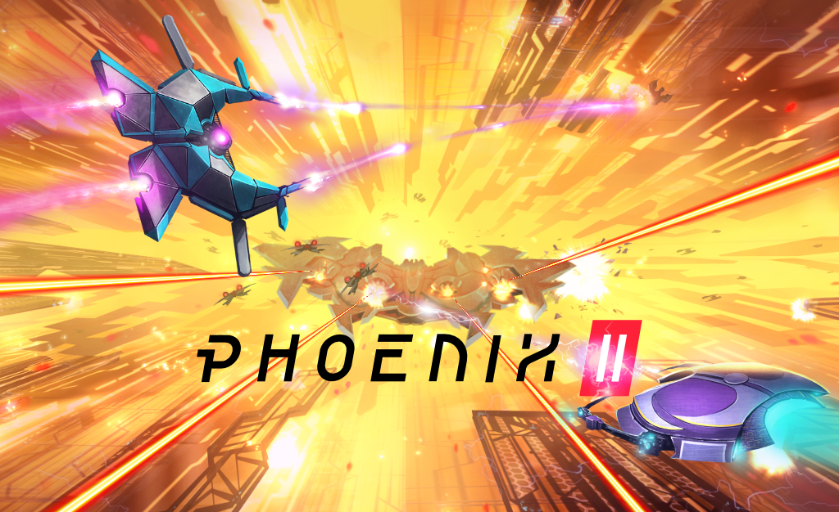

* **Guardian Girls:**This game is the best suited for Anime lovers. The gaming industry has no gender discrimination, and Guardian girls feature girls in a colorful and admiring background that is anime-characters. This game works in a story mode and there are various adventurous happenings in the game like a boss fight in every ten levels. This game has an energetic soundtrack with beautiful background and is the best choice for a beginner in the Bullet Hell games.

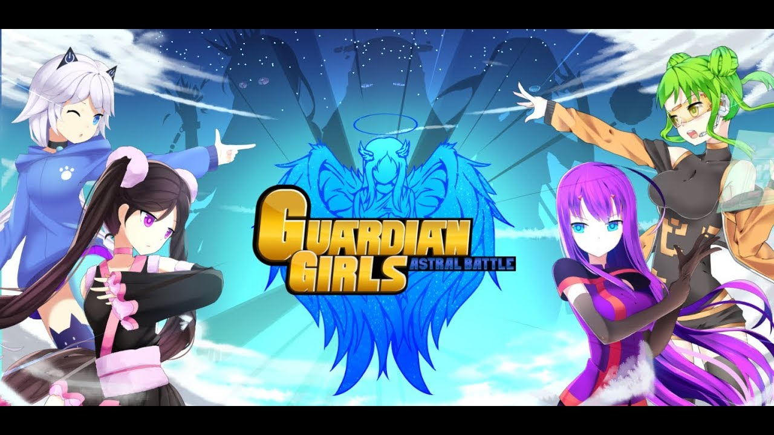

* **ShooMachi:**This is a retro-style shooting game that is too decent and easy to play. This game involves the shooting experiences in the ground and not in the sky unlike most of the Bullet Hell games. Although gaming mechanics are the same, this game is quite simple. This is a storyline about a lazy brave and how he fights his way out, and meanwhile earns the coins with each monster killed or attacked. The game offers various modes, power-ups, and boosts to enhance the playing ability.

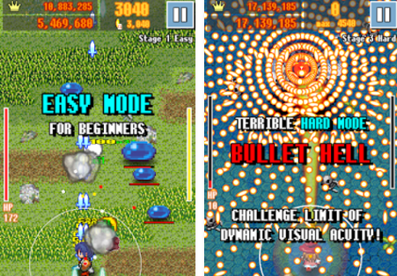

* **Sky Force Reloaded:** Sky Force reloaded is the most popular Bullet Hell game being the latest one in the genre and has several levels to complete, upgradations available for the ships, with cheerful graphics and background audio available. The game has a total of nine ships, various bonus cards, and a range of modes available. The game has a basic classical script like Raiden and 1943. There are various in-app purchases available too that enhance the gaming experience. The controls for this Bullet Hill game, Sky Force Reloaded are simple with simple visuals too.

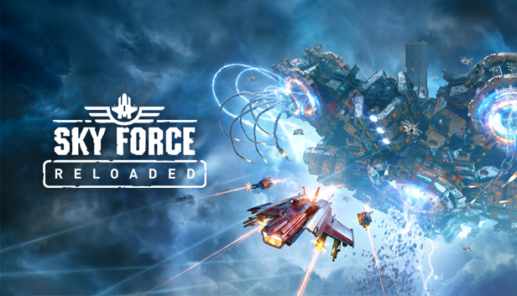

This is the list of top Bullet Hell games as identified by various surveys and reports. With various bullets and explosions going on in the playing screens, these games involve various adventures and energize the player with the enthusiastic songs and energetic gameplay required. Also, being a lot of engaging, these games help people get distracted from mental pressures and thus relieve excessive stress in destroying their lives. These games are all about fighting and shooting the enemies and staying clear of their bullets and explosives to stay longer in the game.

Various game developers offer effective features and technologies for Bullet Hell Mobile games development. Game App Studio has experts in various techniques and gaming mechanics required for every genre in the gameplay, with Bullet hell Games being one of the top recommendations in the list. These games have been proved to attract a huge number of folks with the adventures provided and Game App Studio has excelled in development and marketing techniques to enhance the fan-base to a greater extent.